🚀 Databricks dbutils Series | Part 2
📂 dbutils.fs — Work with Files Like a Pro
Managing files efficiently is a fundamental skill for every Data Engineer.
The dbutils.fs module lets you perform file operations directly from your Databricks notebook.
Today's commands include:
✅ dbutils.fs.ls()
✅ dbutils.fs.mkdirs()
✅ dbutils.fs.cp()
✅ dbutils.fs.mv()
✅ dbutils.fs.rm()
✅ dbutils.fs.head()
✅ dbutils.fs.put()
✅ dbutils.fs.mounts()
✅ dbutils.fs.help()
These commands are commonly used when working with DBFS, ADLS, and production ETL pipelines.
💡 Interview Tip:
Many interviewers ask the difference between cp() and mv(). Understanding when to copy versus move files is an important production skill.
📌 Save this post for quick reference.
💬 Which dbutils.fs command do you use most often?
hashtag#Databricks hashtag#AzureDatabricks hashtag#dbutils hashtag#DBFS hashtag#PySpark hashtag#ApacheSpark hashtag#DataEngineering hashtag#ETL hashtag#Azure hashtag#DataEngineering hashtag#DataEngineer hashtag#Azure hashtag#MicrosoftAzure hashtag#AzureDataFactory hashtag#ADF hashtag#AzureDatabricks hashtag#Databricks hashtag#ApacheSpark hashtag#PySpark hashtag#SparkSQL hashtag#DeltaLake hashtag#Lakehouse hashtag#UnityCatalog hashtag#SQL hashtag#SQLServer hashtag#TSQL hashtag#Database hashtag#DataWarehouse hashtag#DataIntegration hashtag#DataPipeline hashtag#ETL hashtag#ELT hashtag#BigData hashtag#CloudComputing hashtag#DataAnalytics hashtag#ArtificialIntelligence hashtag#AI hashtag#GenerativeAI hashtag#MachineLearning hashtag#LLM hashtag#OpenAI hashtag#AIAgents hashtag#AIEngineering hashtag#Automation hashtag#PromptEngineering hashtag#Technology hashtag#Innovation hashtag#DigitalTransformation hashtag#TechLearning hashtag#CareerGrowth hashtag#InterviewPreparation hashtag#Coding hashtag#AzureDataEngineer hashtag#DataEngineeringCommunity hashtag#DataEngineeringTips hashtag#LearnWithManikanta hashtag#ManikantaRaoGopalam
Activate to view larger image,
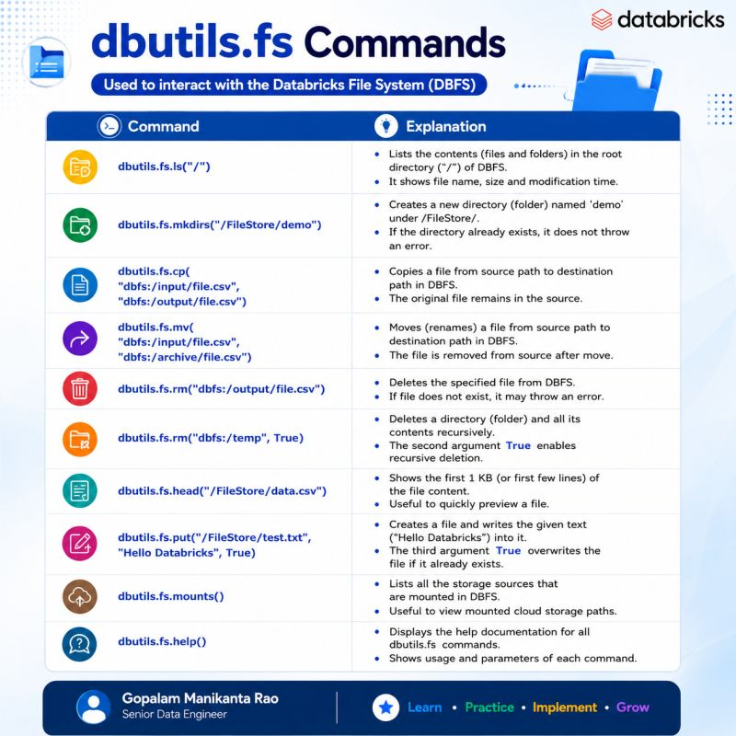

Databricks DBUtils Commands –
I created a comprehensive set of DBUtils handwritten notes covering the most commonly used commands in Databricks for Data Engineers.
📚 Topics Covered:
✅ dbutils.fs
✅ dbutils.secrets
✅ dbutils.widgets
✅ dbutils.notebook
✅ dbutils.library
✅ dbutils.jobs.taskValues
✅ dbutils.data.summarize()
✅ dbutils.credentials.showCurrentRole()
These notes include:
* Simple explanations
* Practical command examples
* Interview-focused content
* Easy-to-revise handwritten format
Perfect for:
✔️ Data Engineering Interviews
✔️ Databricks Beginners
✔️ Azure Databricks Developers
✔️ Daily Revision
hashtag#Databricks hashtag#DBUtils hashtag#PySpark hashtag#DataEngineering hashtag#AzureDatabricks hashtag#BigData hashtag#Spark hashtag#SQL hashtag#ETL hashtag#DataEngineer hashtag#CloudComputing hashtag#Analytics hashtag#DataPlatform hashtag#Learning hashtag#InterviewPreparation hashtag#TechCommunity hashtag#CareerGrowth hashtag#Notebook hashtag#DeltaLake hashtag#ApacheSpark

